HIGH LEVEL DESIGN OF URL SHORTENER

Primary Aim: Converting long URLs into short, unique URLs for easier sharing and management.
- Requirements
A Typical Scenario
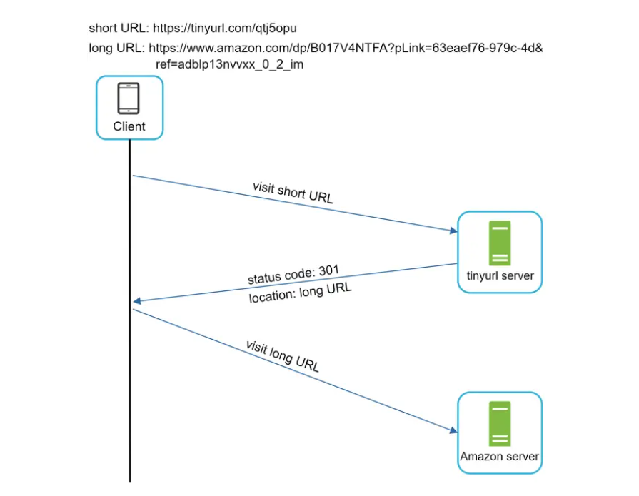

URL Shortening High Level View
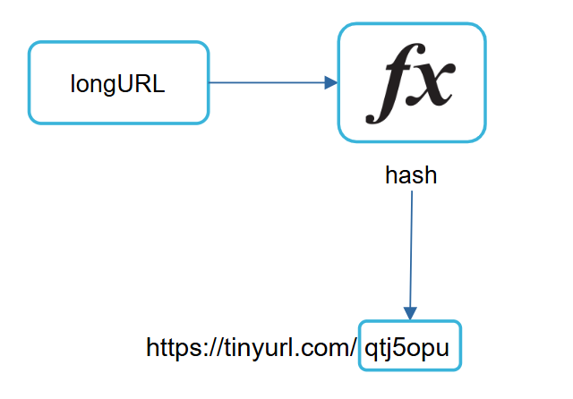
Hash+ Collision Resolution
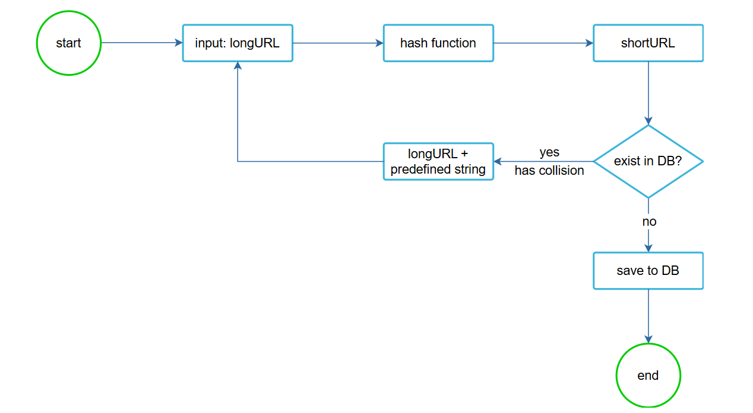


ID- Based Approach
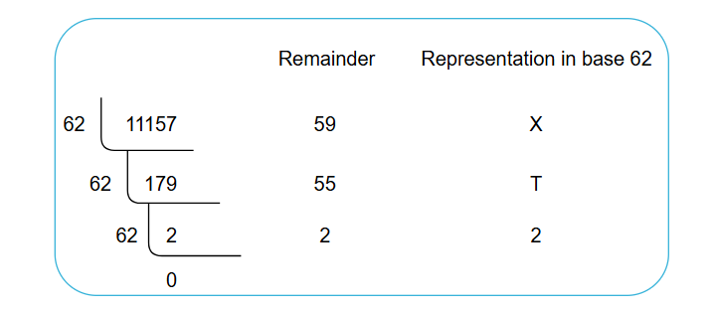

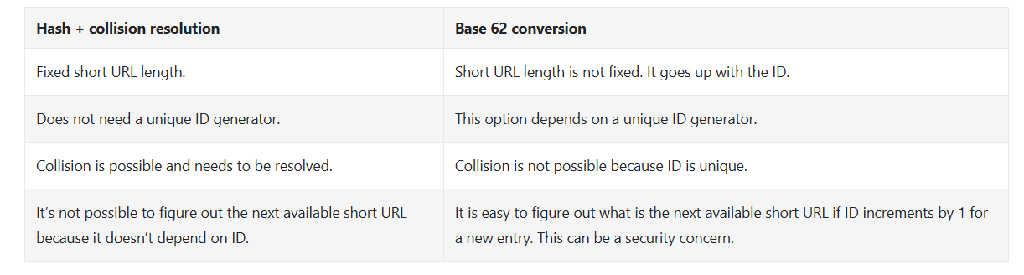
Comparison of two approaches

URL generation engine logic
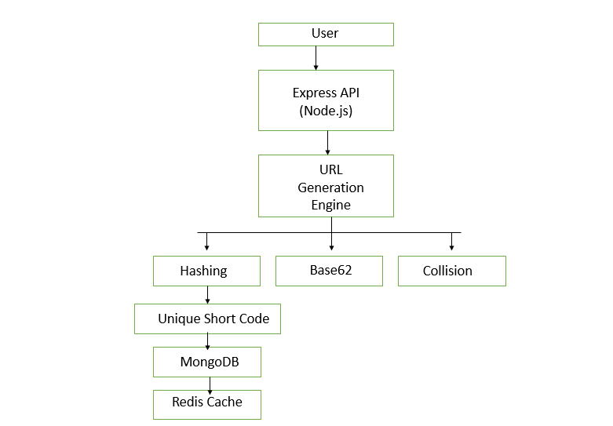

URL redirecting

